Ideation Phase
Empathize & Discover
Date | 31 January 2025
Team ID
Project Name | Script-Controlled ACL – Restrict Record Access Based on Field Value
Maximum Marks | 4 Marks
Empathy Map Canvas:
An empathy map is a simple, easy-to-digest visual that captures knowledge about a user’s behaviours and attitudes.
It is a useful tool to help teams better understand their users. Creating an effective solution requires understanding the true problem and the person who is experiencing it. The exercise of creating the map helps participants consider things from the user’s perspective along with his or her goals and challenges.
Empathy Map – Script-Controlled ACL (User: ServiceNow Administrator / Developer)
What does he THINK AND FEEL?
• “Will restricted records leak to users who should not see them?”
• “Will my script accidentally block legitimate users?”
• Worried about audit findings and data-privacy compliance
• Wants precise, record-level security that is easy to maintain
What does he HEAR?  • Manager: “Sensitive records must only be visible to the right people.”  • Colleagues: “Role-based ACLs are simpler, just use those.”  • Auditors: “Show how access is restricted per record.”  • Users: “I can’t open my own ticket!” | What does he SAY AND DO?  • Writes ACL scripts that check a field value (e.g., Confidential) using current.<field>  • Sets answer = true / false based on user role and field value  • Tests with impersonation and different roles  • Reviews ACL evaluation order and system logs | What does he SEE?  • Role-only ACLs exposing every record in a table to all role holders  • Sensitive records visible in lists and reports  • Inconsistent results between users  • ACL script errors and hard-to-trace denials in logs
PAIN  • Role-based ACLs are too coarse for record-level rules  • Scripts are hard to test and debug  • Fear of over-blocking or leaking data  • Confusing ACL evaluation order | GAIN  • Only authorized users see records with restricted field values  • Compliance and audit confidence  • Least-privilege access with clear, reusable logic  • Fewer support tickets about access issues
Reference: https://www.mural.co/templates/empathy-map-canvas
Ideation Phase
Define the Problem Statements
Date | 31 January 2025
Team ID
Project Name | Script-Controlled ACL – Restrict Record Access Based on Field Value
Maximum Marks | 2 Marks
Customer Problem Statement Template:
Create a problem statement to understand your customer's point of view. The Customer Problem Statement template helps you focus on what matters to create experiences people will love.
A well-articulated customer problem statement allows you and your team to find the ideal solution for the challenges your customers face. Throughout the process, you’ll also be able to empathize with your customers, which helps you better understand how they perceive your product or service.
Reference: https://miro.com/templates/customer-problem-statement/
Problem Statement – Script-Controlled ACL:
Problem Statement (PS) | I am (Customer) | I’m trying to | But | Because | Which makes me feel
PS-1 | A ServiceNow administrator responsible for data security | Restrict access to records based on the value of a field (e.g., Confidential) | Role-based ACLs give every role holder access to all records in the table | Standard ACL conditions cannot evaluate record-specific field values without a script | Worried and exposed to data-leak risk
PS-2 | A ServiceNow developer who writes and maintains ACLs | Write a script-controlled ACL that allows or denies access correctly | The script is hard to test and may block legitimate users or miss restricted ones | ACL scripts depend on evaluation order, roles and live field values, with limited debugging visibility | Anxious and uncertain about the result
PS-3 | A service desk agent / end user | Open only the records I am authorized to see and work on | I sometimes get denied on my own records or see records I should not | The ACL script rules and exceptions are not defined or applied consistently | Confused and frustrated

Ideation Phase
Brainstorm & Idea Prioritization Template
Date | 31 January 2025
Team ID
Project Name | Script-Controlled ACL – Restrict Record Access Based on Field Value
Maximum Marks | 4 Marks
Brainstorm & Idea Prioritization Template:
Brainstorming provides a free and open environment that encourages everyone within a team to participate in the creative thinking process that leads to problem solving. Prioritizing volume over value, out-of-the-box ideas are welcome and built upon, and all participants are encouraged to collaborate, helping each other develop a rich amount of creative solutions.
Use this template in your own brainstorming sessions so your team can unleash their imagination and start shaping concepts even if you're not sitting in the same room.
Reference: https://www.mural.co/templates/brainstorm-and-idea-prioritization

Step-1: Team Gathering, Collaboration and Select the Problem Statement
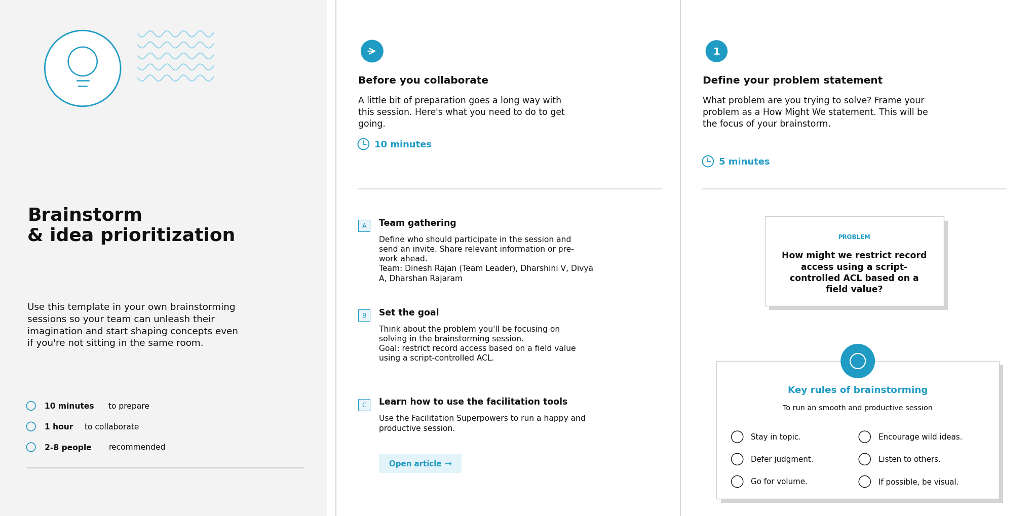

Step-2: Brainstorm, Idea Listing and Grouping
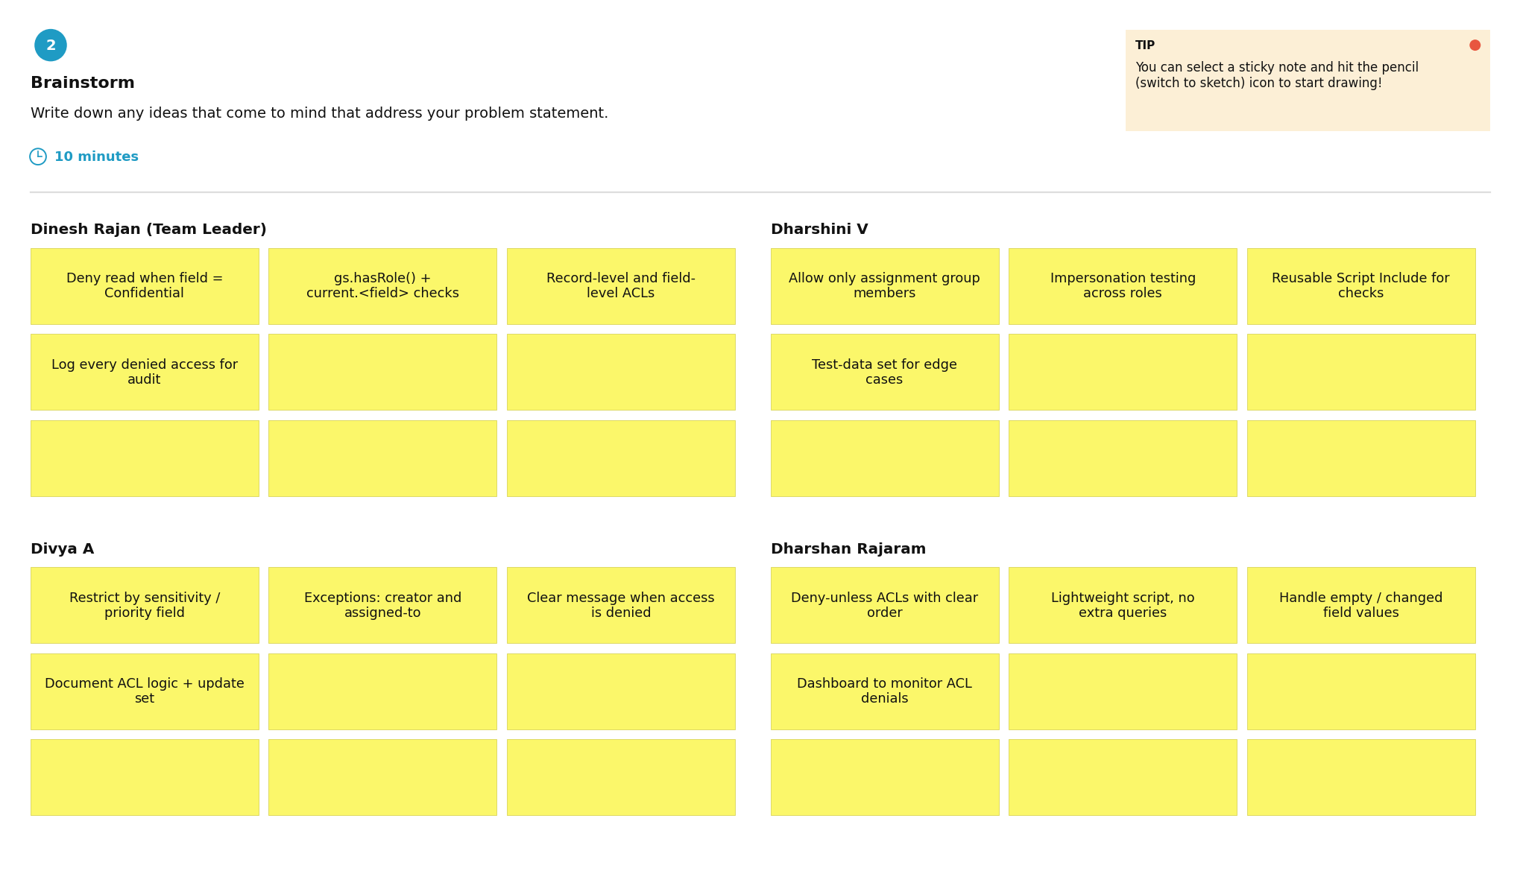

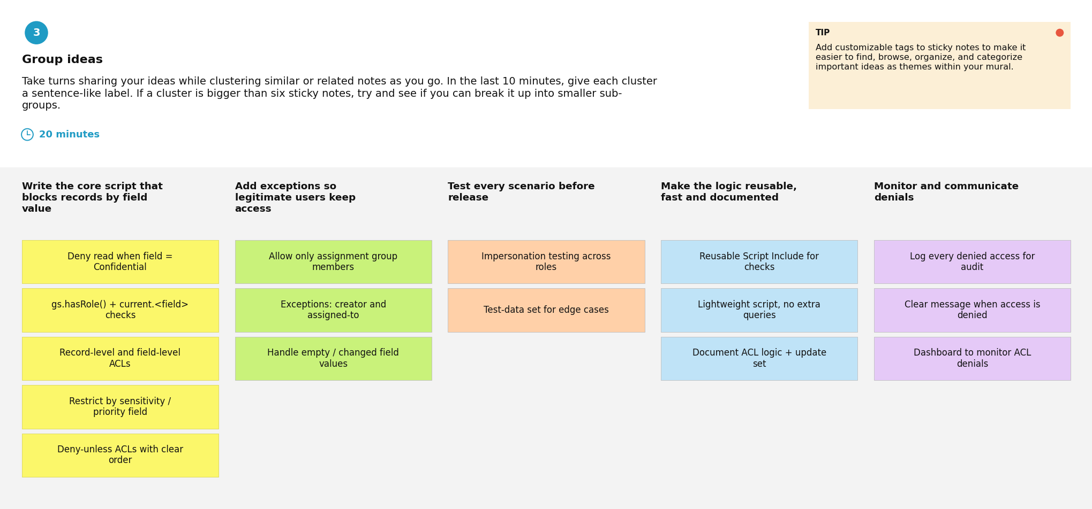

Step-3: Idea Prioritization
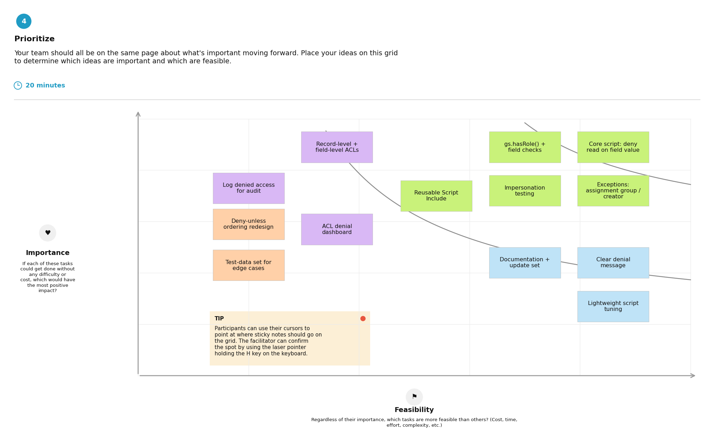
Sticky-note colours: green = high importance and high feasibility (do first); purple = high importance, lower feasibility (plan next); blue = lower importance, high feasibility (quick wins); orange = lower importance and feasibility (reconsider).

Project Task Assignment – Milestones
Milestone (Epic) | Task | Assigned to | Time | Level | Status
Milestone-1: Creation of Users and Roles | Users Creation | Divya A | 30m | Easy | To do
Milestone-1: Creation of Users and Roles | Roles Creation | Divya A | 30m | Easy | To do
Milestone-2: Tables Creation | Creation of Table | Dharshan Rajaram | 20m | Easy | To do
Milestone-3: Creation of Access Control List - READ | ACL Configuration (READ) | Dharshan Rajaram | 1h 0m | Easy | To do
Milestone-4: Creation of Access Control List - CREATE | Creation of ACL - Create | Dinesh Rajan (Team Leader) | 6h 4m | Easy | To do
Milestone-5: Creation of Access Control List - WRITE | Creation of ACL - Write | Dharshini V | 3h 0m | Easy | To do
Milestone-6: Creation of Access Control List - DELETE | Creation of ACL - Delete | Dharshini V | 30m | Easy | To do
Milestone-7: Conclusion | Project Outcome | Dinesh Rajan (Team Leader) | 10m | Easy | To do

